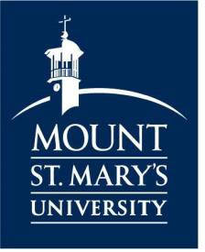
HELPFUL NEW STUDENT INFORMATION

FOR CATHOLIC HIGH SCHOOL DUAL ENROLLMENT STUDENTS

STUDENT RESOURCES
STUDENT RESOURCES

- Email: After acceptance, your Mount email address & password will be sent to the email address that you provided on your admissions application. To access your email account, go to live.msmary.edu and log in with your email address and password. At this point all correspondence from Mount St. Mary's University will be sent to your Mount email account.
- MyMount: MyMount can be accessed by going to mymount.msmary.edu and logging in with your username and password. Please note, when logging into MyMount, only use your username and not your entire email address. The following information can be found on MyMount: registration, course schedule, account balance, make payments, final grades, unofficial transcript, online FERPA release form and various other student forms.
- Canvas: Canvas is the Mount’s learning management system (LMS) used for each course. The following information can be found on Canvas: course syllabus; instructor information; online course materials; required readings & assignments; test, quiz & assignment grades. Courses are visible 1-2 weeks prior to the class start date. Log in to
- Canvas by going to msmary.instructure.com and using your full Mount email and password. 24/7 support for Canvas is available by clicking the Help icon while logged in.
- Informational Technology Support Center: For technological support, contact ITSC by submitting a service ticket or call
301-447-5805.
- Registration: Course registration for Catholic High School Dual Enrollment Students occurs in collaboration with the high school guidance counselor for fall and spring semesters, per the Memorandum of Understanding. A pre-approved list of names and registrants is sent to Professor Elizabeth C. Monahan by the designated high school counselor. *NOTE: All Catholic High School Dual Enrollment Students must contact Professor Elizabeth C. Monahan, Director of the Center for Catholic School Excellence, at 301-447-3416 or monahan@msmary.edu, with questions related to course registration.
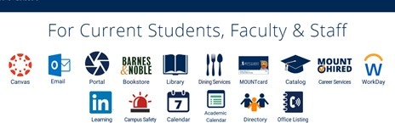
- Bookstore: You can purchase your textbooks, school apparel and supplies from the online Mount bookstore. Professors register their required textbooks with the bookstore, so you can search your courses online and easily find your textbooks. Visit the bookstore’s course materials webpage msmu.bncollege.com/shop/msmu/page/fin d-textbooks.

