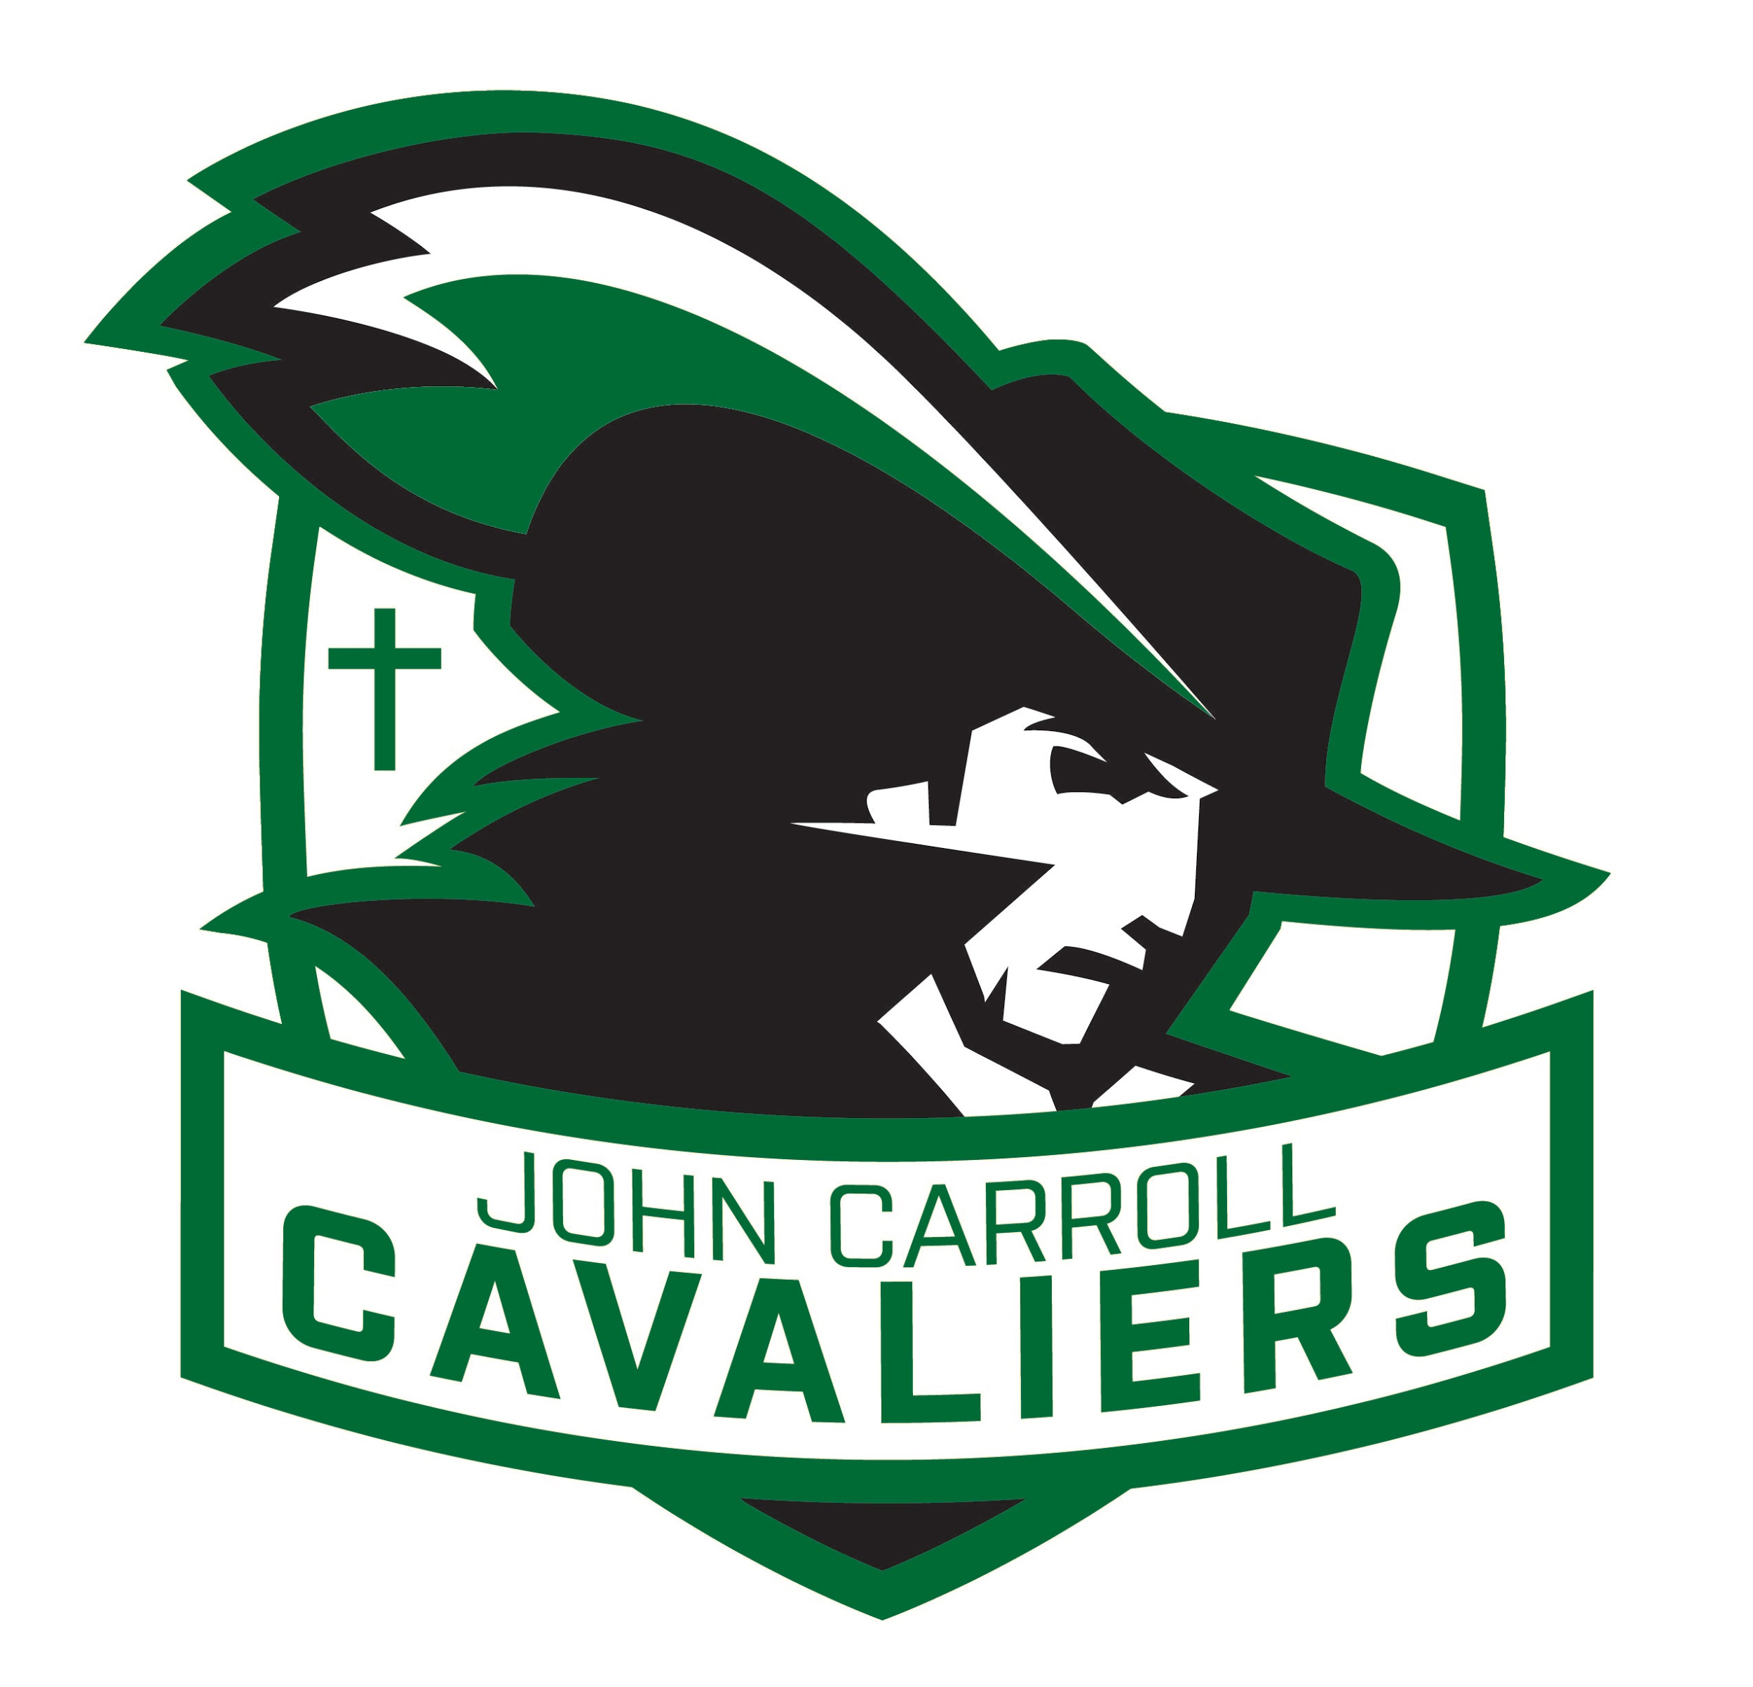
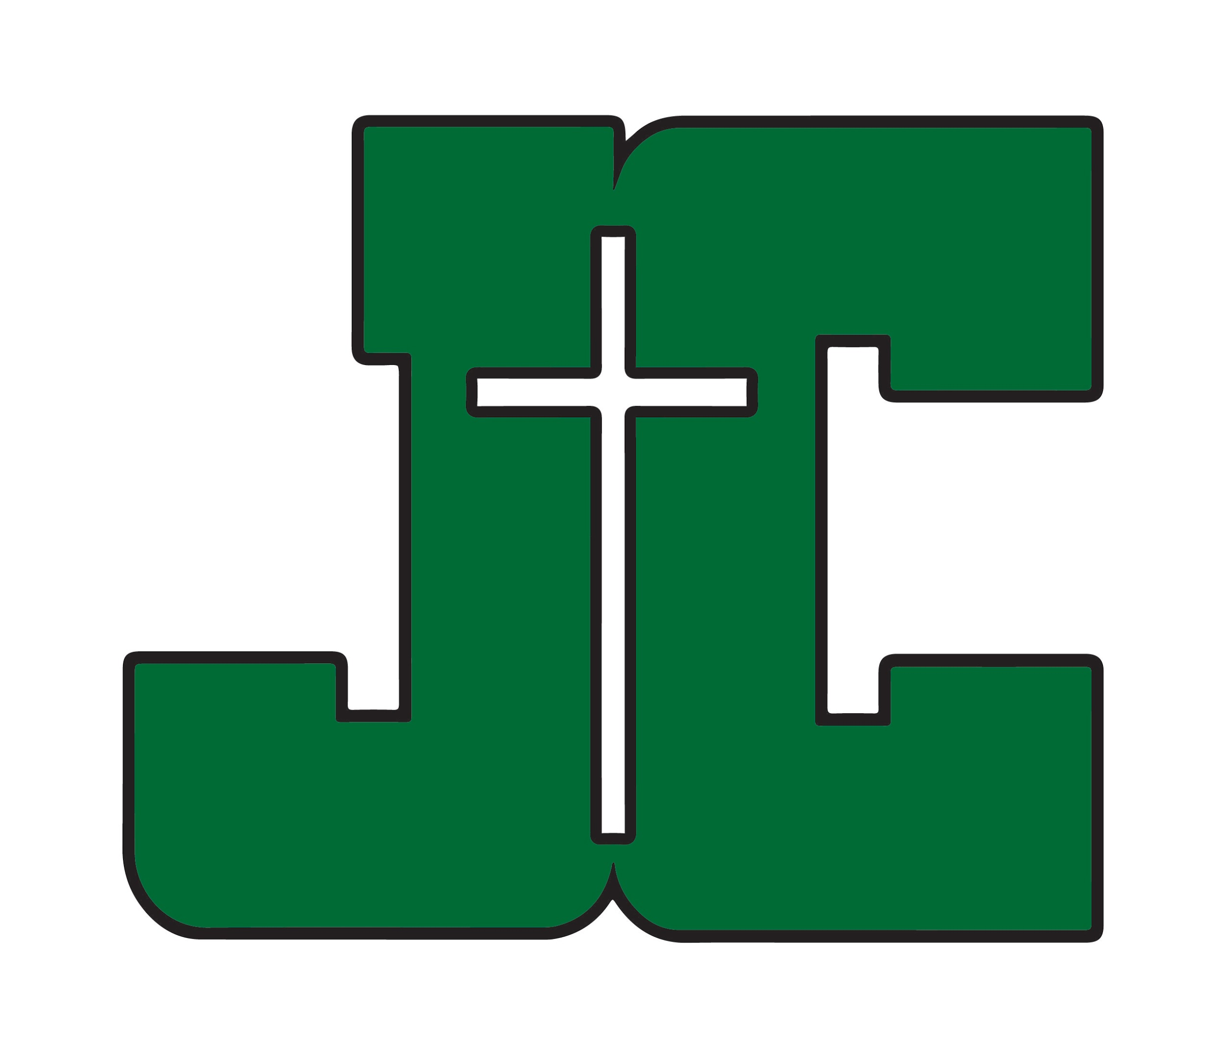
John Carroll Catholic High School
April Newsletter and Calendar
Home of the Cavaliers

Anthony Montalto, Principal 300 Lakeshore Parkway amontalto@jcchs.org Birmingham, AL 35209
205- 940-2400

April 1, 2022
Dear Students and Parents,
The school will be closed tomorrow as we are enjoying our Bishop’s Holiday and preparing for our Junior Senior Prom. Only 6 weeks till graduation. Let’s make the end of this school year the best ever.
Anthony Montalto – amontalto@jcchs.org

Dress Code Next Year - I want to make everyone aware of a couple items that are included in the Student Dress Code that will be required next year.
- Dress shoes or Sperry’s must be worn. All shoes regular or orthopedic must be brown or black. If you have an orthopedic condition, have your doctor prescribe or recommend special dress shoes or inserts. Tennis shoes are not allowed
- Brown or black belts only. No large or designer buckles.
- Earrings –
  - Boys - No earrings for boys
  - Girls – A single earring may be worn on the lower lobe of the ears only. No large loops,
- Skirts and shorts may be no shorter than 3 inches above the knee.
- No Tattoos

Exam schedule – Open this attachment to view the exam schedule.

Campus Ministry
- Praise and Worship by Sarah Kroger with Eucharistic Adoration- April 20th from 6:30-8:00pm in the JC gym. Confessions available. All in the community are welcome to join us.
- Senior Class Retreat: April 22nd at Springville Camp and Conference Center. Seniors and senior parents, refer to email from Ms. King sent 3/22.

Choir News –
- Auditions for Honors Mixed Choir will be held next week - April 11, 12 and 13. Sign up times will be on the choir room door.
- Try Choir for Easter – See Mrs. Hughes for more information. April 19 and 20, During Homeroom. We will be singing “10,000 Reasons”
- Spring Concert is Monday April 25 at 7:00pm in the auditorium.
- Honors Mixed will be leading Prince of Peace Mass on the morning of April 27.

Athletic Booster Club Casino Night – This adult only event is April 30th from 6:30-11:00 PM in the JC Commons. This link ( Webpage for Casino Night ) can be used to purchase tickets to the event, become a sponsor for the event, and/or donate prizes.
Honor Society Inductions - Our French, Latin, and Spanish Honor Societies along with the Carroll Chapter of the National Honor Society will celebrate new members at a shared induction ceremony during the activity period on Wednesday, April 27th at 9:10 AM.

Join the JCCHS Colorguard! The Colorguard will hold clinic tryouts April 25th-29th. In addition, Colorguard members will be hosting FREE lessons on April 7th, April 12th, and April 21st. The lessons are not mandatory for tryouts, but they are a great way to get comfortable with the flag skills before tryouts. All meetings will start in the JCCHS band room. Contact Kelly Gronemeyer at kgronemeyer@jcchs.org for more information!

Dual Enrollment – Check out this link for information on Dual Enrollment opportunities https://www.jcchs.org/academics/dual-enrollment
75 Service Hour Graduation Requirement- Service is a beautiful way for John Carroll to express its loving and Catholic identity. All students are expected to complete 75 hours of service in order to be eligible for graduation. If you aren't sure how many hours we have recorded you can check them on your Renweb profile under "Family Information." There are always opportunities to serve and engage our communities. Find more information about the requirements and possibilities for service on the JCCHS website.

Now is the time to start planning how you might tackle your service requirements over the summer. If you have project ideas or organizations that you know need other support let us know and we can help get the word out. We'd like to encourage students to be creative (and safe) in how they serve our neighbors in need. If you've got an idea for service contact Mr. Cashio - pcashio@jcchs.org or Ms. King and they will do their best to make it a possibility.

Some Service Opportunities –
- Food for Our Journey -Monday morning collection of premade lunches and hygiene kits. Items can be dropped off at JCCHS on Monday mornings before school. Contact Christine Golab.
- STAIR- Start the Adventure in Reading -This awesome literacy program connects you directly with a second grade student to help them build their literacy skills. Contact - Kelli Bell –.
- Fransican Friars of the Poor - Serve our homeless brothers and sisters on Saturday evenings - Contact. Ms. McCarrick
- United Way Hands - On is a great web resource for finding service projects around our area.
- Habitat for Humanity - Pope Francis Build - Every year during Lent Catholic Communities around Birmingham work together to build a home with Habitat for Humanity. John Carroll students are encouraged to participate with their parishes and families. Sign up at Habitat Birmingham or contact Katie Elsea.

Job Openings for 2022 – 2023 School Year
- History teacher
- Science teacher
- Bus driver

Yard Sale- If you are interested in purchasing any of the items below, please let me know – amontalto@jcchs.org

- Cheerleader Mats – We have six used foot’ by 42foot Cheerleader Practice mats for sale for $100 each.
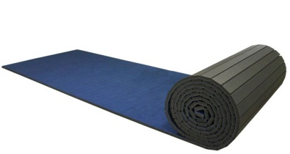

April Calendar and Lunch Menu Below
GO CAVS

April Calendar

Monday 4 | Tuesday 5 | Wednesday 6 | Thursday 7  Mass Day  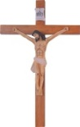  Color Guard Lessons | Friday 8  Bishop’s holiday  School Closed!  Junior Senior Prom | Saturday 9
 |  |  |  |  | Sunday 10
Monday 11  Athletic Booster Club Meeting  6:00 PM | Tuesday 12  Cavs For A Cure Jeans Day | Wednesday 13  Assembly  Stations of the Cross | Thursday 14  Pre ACT Test  Holy Thursday  1:00 Dismissal | Friday 15  Good Friday  School Closed | Saturday 16
Sunday 17

EASTER SUNDAY

Monday 18  Easter Monday  School Closed | Tuesday 19  Candy Cones  Spirit Truck 3:00 | Wednesday 20  Clubs  Praise and Worship Night in the Gym  6:30 PM  PTO 6:15 PM | Thursday 21  Mass Day  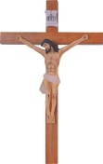  Color Guard Lessons | Friday 22  Catholic Schools Field Day  Senior Retreat  Springville | Saturday 23  Cavs For A Cure  8th Grade Dance
 |  |  |  |  | Sunday 24
Monday 25  Color Guard Clinic 3:45 – 5:15  Color Guard Parent Meeting 5:00 – 6:00  MS Boys Basketball Tryouts 5:00 – 7:00 | Tuesday 26  Color Guard Clinic 3:45 – 5:15  MS Boys Basketball Tryouts 5:00 – 7:00 | Wednesday 27  Red Cross Blood Drive  Honor Society Inductions  Color Guard Clinic 3:45 – 5:15  MS Boys Basketball Tryouts 5:00 – 7:00 | Thursday 28  Mass Day  Band Concert 7:00 PM  Color Guard Clinic 3:45 – 5:15  MS Boys Basketball Tryouts 5:00 – 7:00 | Friday 29  Color Guard  Try-outs  4:00 – 5:30  MS Boys Basketball Tryouts 5:00 – 7:00 | Saturday 30  Casino Night
Sunday, May 1

Super Jazz 1:00 PM

APRIL Lunch Menu
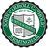
 | MONDAY | TUESDAY | WEDNESDAY | THURSDAY | FRIDAY
WEEK OF  4/4/2022 | 4  Red Beans & Rice w. Sausage  Roasted Broccoli  Dinner  Roll | 5  Greek Chicken  Mashed Potatoes  Green Beans  Dinner Rolls  Dessert | 6  Baked Ziti  Garlic Bread  Broccoli  Garden Salad | 7  Chili Cheese Dogs  Chips  Slaw  Brownie | 8  NO SCHOOL
WEEK OF  4/11/2022 | 11  Cheese Enchilada Casserole  Mexican Rice  Re Fried Beans  Churrro | 12  Spaghetti & Meat Sauce  Garlic Bread  Broccoli  Dessert | 13  Orange Chicken  Fried Rice  Mixed Veg.  Fortune Cookies | 14  Sweet Chili Glazed Pork Loin  Rice  Peas  Roll | 15  NO SCHOOL
WEEK OF  4/18/2022 | 18  NO SCHOOL | 19  Meatloaf  Broccoli  Mashed  Potatoes  Fruit | 20  Pasta Alfredo  Garden Salad  Roll  Roasted Veg.  Dessert | 21  Loaded Potato  Green Beans  Roll  Fruit | 22  Teriyaki Chicken  Fried rice  Fruit  Fortune Cookie
WEEK OF  4/25/2022 | 25  Sliced Ham  Mac n’ Cheese  Green Beans  Roll | 26  Fried Pork Chops  Loaded Potato Casserole  Broccoli  Dinner Roll | 27  Beef and Broccoli  Rice  Fruit  Fortune cookie | 28  CHICKEN NACHO BAR | 29  VEGE PLATE  Sweet Potato Casserole  Fried Okra  Roasted Broccoli  Slaw  Roll  Dessert

